WFS Wesleyan Financial System
Help for Transaction Detail Inquiry Page
The Transaction Detail page gives all the detail about every line of a transaction. This is the most detailed information of all the Inquiry pages.
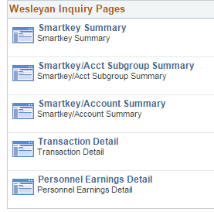
This document provides detail help for Transaction Detail page.
The search criteria allow the user to select transactions based on a number of different criteria. Once the criteria are applied the user can see the type of document, document number, vendor, dollar amount, dates for budget checking and approval, etc. The search for data can start with the SmartKey, department number, account or other fields. The chart below gives a column-by-column explanation of each data field. The “Search Criteria?” column indicates whether you can search using this field in the Basic Search or Advanced Search.
The drill-down next to the Document ID will show all the lines associated with that document regardless of the SmartKey and account. The user will only see the detail for lines to which they have security access.
Drill-down to see all transactions on the document. A new window will open
